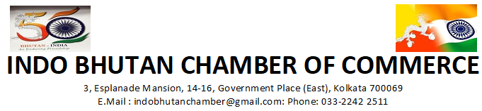

India–Bhutan Trade (FY 2024–25)
Trade between India and Bhutan remains one of South Asia’s most stable and strategic economic partnerships. Governed by the India‐Bhutan Agreement on Trade, Commerce and Transit, both countries enjoy duty-free access and simplified regulations, fostering strong cross-border flows of goods and services. India continues to be Bhutan’s largest trading partner, accounting for around 80 % of Bhutan’s overall trade.

Total Bilateral Trade
- Total India-Bhutan bilateral trade was approximately USD 1.90 billion (₹15,000crore) in FY 2024-25 (India’s exports + imports).
- This represents a significant expansion over the past decade (from USD 484 million in FY 2014-15 to nearly USD 1.9 billion in FY 2024-25).

India’s Exports to Bhutan
- India’s exports to Bhutan were about USD 1.26 billion in FY 2024-25.
- These include key categories such as petroleum products, machinery and equipment, iron & steel, electrical goods, vehicles and cereals as core components supporting Bhutan’s infrastructure and industrial needs.

India’s Imports from Bhutan
- India’s imports from Bhutan stood at approximately USD 641.7 million in FY 2024-25.
According to UN Comtrade data for calendar year 2024, imports from Bhutan were about USD 435.6 million, with major products including iron and steel, aerospace parts, cement/raw materials, beverages, and wood products.
…2

-2-
Major commodities included:
- Petroleum products
- Motor vehicles and spare parts
- Machinery and equipment
- Construction materials (steel, cement inputs)
- Food products and FMCG goods
- Pharmaceuticals
- Consumer goods
- Food and agricultural products
This diverse export basket reflects India’s role as a supplier of essential industrial and consumer goods.
Major imports from Bhutan comprised:
- Hydropower (electricity – largest component of trade)
- Ferro alloys
- Cement
- Dolomite
- Cardamom
- Minerals and base metals

India’s Cement Imports from Bhutan (FY 2024–25)
Category | HS Classification | Value (USD Million) | Quantity | Remarks
Cement & related stone products | HS 25 (Salt, sulphur, earth, stone, lime & cement – broad category) | 93.8 | NA | Includes cement along with other mineral products
Hydraulic cement (Portland, aluminous, slag, etc.) | HS 2523 | 18.1 |  | More precise cement-specific classification
Cement clinkers | HS 252310 | 2.95 | 53,509 tonnes | Physical quantity reported under clinker imports
Other Category
Hydropower (Electricity) |  | 425 (approx.) |  | Largest import component; backbone of bilateral trade
Ferro Alloys |  | 175 (approx.) |  | Primarily ferro silicon; major industrial input
Other Imports |  | 20.6 |  | Dolomite, cardamom, minerals, etc.

The India-Bhutan trade partnership continues to grow and remains strategically important. Official trade figures for 2024-25 show rising volumes on both sides, reflecting sustained engagement. Addressing practical barriers and promoting diversification will help businesses leverage this long-standing economic cooperation.

***

